FAMU/FSU College of Engineering
Department of Mechanical Engineering
Operation Manual
Team 516: NASA-MSFC Electrical Capacitance Tomography for Cryogenic Fluids
Names: Contact Email:
Bryson Peters btp20@fsu.edu
Zafer Jesri zj18a@fsu.edu
Dane Seal ds18k@fsu.edu
Catherine Potts cp19s@fsu.edu
Trevor Lay tjl19b@fsu.edu
3/3/2023

Project Overview
The project objective is to design a support structure for a Fiber Optic Sensing System (FOSS). The FOSS is the current method that the National Aeronautics and Space Administration (NASA) uses to measure the amount of cryogenic fuel (propellant) remaining in a storage tank. The FOSS consists of a fiber optic cable that has Bragg sensors evenly spaced along the length of the 5-foot cable. These Bragg sensors measure the strain of the cable, which directly correlates to the temperature of the fuel. This temperature determines if the propellant is in a liquid or gaseous state. The fuel that is in a gaseous state is considered non-viable fuel. By determining how much of the propellant is in a gaseous state, the amount of liquid fuel remaining can be determined. The design consists of two pairs of two concentric circles (inner and outer rings), with each pair connected by eight support rods. Each inner-ring to outer-ring connection is held together by four connecting rods. Along the support rods are FOSS hooks, which are cylindrical keys that both connect to the support rods at varying heights and guide the FOSS cable throughout the structure in a helical fashion. All the structure is made from G-10 because of its low thermal conductivity and high survivability under cryogenic conditions. The current testing procedure is designed to be done at the National High Magnetic Field Laboratory (MagLab). To begin testing the structure, a dewar is filled with liquid nitrogen (LN2). It is then lowered into the dewar with the FOSS system attached. The dewar is placed on a scale to get an accurate reading of the mass of LN2. The data is then compared to the mass readings from the FOSS system. This experiment does two things: determines the error of the FOSS system and tests the structural stability of the design.
Component Description
The prototype designed in CREO Parametric can be seen below in Figure 1. The prototype consists of two outer support rings, two inner support rings, eight connector rods, eight stabilizing rods, and eight FOSS hooks.
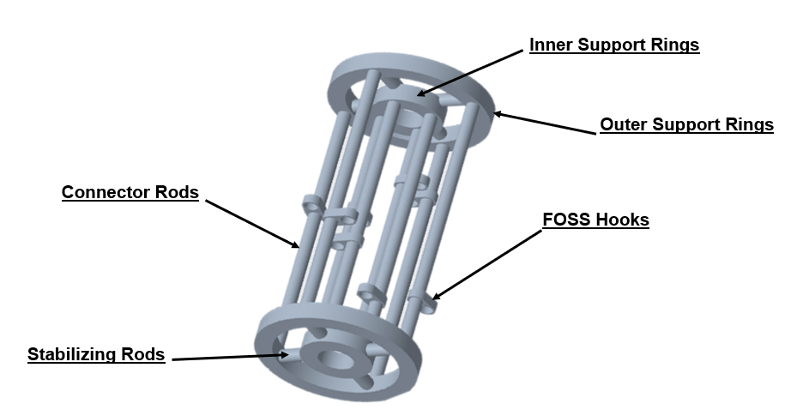
Figure 1: CAD Prototype
The total height of the prototype is 14 inches, and the largest width is 12 inches. There is a difference of 2 inches between the connecting rods on the inner and outer support rings. However, this value can be scaled up or down depending on the desired accuracy levels. Having two helix shapes allows the FOSS cable to travel in two degrees of freedom: vertically and radially through the tank. The individual components of the prototype are detailed below.
The first components are the inner and outer support rings. These are used to give the structure two separate diameters so the FOSS cable can run radially along the storage tank. The two support rings are shown in Figure 2.
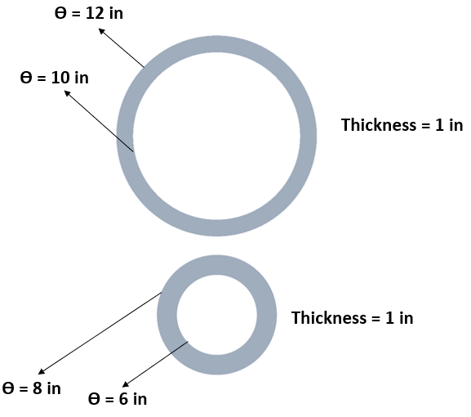
Figure 2: Outer Support Ring (pictured on top) and Inner Support Ring (pictured on bottom)
The outer support ring has an outer diameter of 12 inches and an inner diameter of 10 inches, which gives it a thickness of 1 inch. The inner support ring has a 1-inch thickness too, with an outer diameter of 8 inches and an inner diameter of 6 inches. Both rings have a depth of 1 inch. These thicknesses were chosen to increase structural stability of the support system. The diameters were chosen to give a 1-inch thickness to both rings and have a difference of 2 inches to allow the FOSS system to travel radially 2 inches. There are two inner support rings and two outer support rings in the prototype.
The connector rods are used to connect the inner support rings and the outer support rings. The stabilizing rods are used to connect the respective pairs of inner and outer support rings. The connector rods and stabilizing rods are shown in Figure 3.
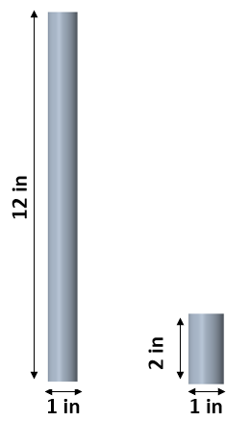
Figure 3: Connector Rods (pictured on left) and Stabilizing Rods (pictured on right)
The connector rods have a 1-inch diameter to be in full surface contact with the surfaces of the inner and outer support rings. The connector rods have a length of 12 inches to optimize the vertical distance measured by the FOSS cable. There are eight connector rods placed equidistant along the surfaces of the outer support ring to maximize structural stability. This pattern is mirrors at a 45-degree angle on the inner support ring, so the cable can cover a maximum amount of area. The stabilizing rods have a diameter of 1 inch to be in full surface contact with the inner surfaces of the outer support rings and the outer surfaces of the inner support rings. The stabilizing rods are 2 inches long and connect the inner and outer rings. There are eight stabilizing rods, which are connected equidistant around the circumference of the inner and outer support rings to maximize structural stability.
The FOSS hooks are used to guide the cable along the structure at various heights and depths. The FOSS hook is shown in Figure 4.
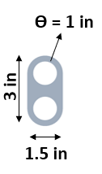
Figure 4: FOSS Hook
The FOSS hook has a total length of 3 inches so that it can house two holes with a diameter of 1 inch. The width is 1.5 inches to support the two holes. One of the holes is used to connect onto the connector rods and be placed at a desired height along each rod. These would ideally be placed equidistant and in an ascending order so that the cable can travel vertically. The second hole is used to guide the FOSS cable without providing any tension. The FOSS cable weaves through the second hole of each FOSS hook so that it takes the shape of a helix. The holes are large enough to provide slack in the cable so that it has room to shrink under cryogenic conditions.
All dimensions provided above were determined by multiple factors. The structure needed to be stable enough to support its weight and height and not fracture due to external forces. The forces of launch would have the largest effect on the structure. The dimensions also relied on the accessibility of the desired material. The larger diameters, lengths, and thicknesses resulted in more expensive material cost. Keeping the structure small allows for inexpensive and multiple prototypes to be made. The structure is designed to be scaled volumetrically to desired dimensions.
Integration
The eight connector rods are manufactured from eight cylindrical 1” by 12” G-10 rods from Fastenal. Despite these rods coming properly dimensioned, additional machining may be needed due to tolerances. The eight stabilizing rods are manufactured from one cylindrical 1” by 24” G-10 rod from Fastenal. The eight stabilizing rods have a length of 2”, allowing these to be cut from one G-10 rod. The remaining parts are manufactured from one rectangular 1” x 24” x 24” G-10 sheet from Fastenal. The two outer support rings can be manufactured from the sheet. The two inner support rings can be machined concentrically inside of the outer support rings. The remaining sheet is used to manufacture the eight FOSS hooks. Since the hooks have a length of 3”, all eight can be cut from the sheet. After being cut from the sheet, these hooks can then have their respective 1” holes bored into them. The rounding on the outside of the FOSS hooks is not necessary but is desired for weigh reduction and aesthetic purposes.
After all parts have been properly machined, assembly can take place. A two-part Stycast epoxy is used since it can withstand cryogenic conditions. The epoxy used was provided by the MagLab. The epoxy must first be put in a vacuum chamber to pull air bubbles out. Pulling the air bubbles out results in a stronger epoxy that holds the structure together more efficiently, giving it better strength for cryogenic testing. Four connector rods are first placed onto one of the outer support rings and sealed with epoxy. Four FOSS hooks are then placed on the connector rods at varying heights, to allow the FOSS cable to travel in a desired path. The FOSS hooks are then sealed with epoxy. Four connector rods are then placed onto one of the inner support rings and sealed with epoxy. The remaining FOSS hooks are then placed onto these connector rods at desired heights and sealed with epoxy. Each connector rod should have one FOSS hook. The second outer support ring is then placed on top of the rods connected to the first outer support ring and sealed with epoxy. The same is done with the second support ring and the remaining connector rods. The two structures are then connected with the eight stabilizing rods and sealed with epoxy to become one structure. The stabilizing rods are placed equidistant along the sides of the support rings to connect them. After the epoxy has dried, the prototype has been assembled.
Operation
The FOSS system is small and very fragile and must be handled with care. The fiber optic cable can be carefully weaved through the FOSS hooks to make the desired path of the cable. The cable is then connected to a data acquisition system that reads and interprets the signal of the FOSS cable. The prototype needs to be handled with care when testing and operating with the FOSS cable. Ensure all proper connections are made on the FOSS system before beginning any testing procedure. Ensure that the epoxy has fully hardened before maneuvering the prototype to the testing facility. If the prototype or FOSS cable has been subject to cryogenic conditions, ensure that they are transported with proper care and reach normal operating temperatures before proceeding. When working with epoxy, testing the FOSS cable, or working with the prototype, ensure a designated workspace has been determined and only authorized personnel operate. Proper personal protection equipment should be used when handling any aspect of the project, whether it is assembly, testing, or maintenance.
Troubleshooting
If the prototype dissembles, check the epoxy connections, and ensure proper amounts of epoxy and the appropriate epoxy were used. If the FOSS system troubleshoots, ensure the data acquisition system is properly connected to both the cable and the power supply. If a component is not properly dimensioned, ensure the CAD drawings are accurate and contain the proper dimensions.

